Project 1: Sales Performance by Region
Objective: Find the total sales for each region and then rank the sales by region. Explanation: This project combines a standard GROUP BY aggregation with a window function for ranking.

SELECT * FROM sales;
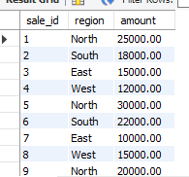

First, find the total sales per region using GROUP BY and SUM().
SELECT region, SUM(amount) AS total_sales FROM sales GROUP BY region;
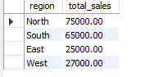
Window Function: Now, wrap the first query as a subquery (or CTE) and apply a window function to rank the regions by their total sales.
SELECT *, RANK() OVER (ORDER BY total_sales DESC) AS sales_rank FROM ( SELECT region, SUM(amount) AS total_sales FROM sales GROUP BY region ) AS regional_sales;

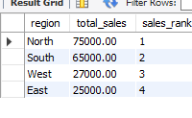

Project 2: Customer Purchase History Analysis

SELECT * FROM orders;
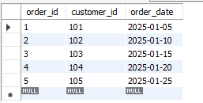

WITH ordered_orders AS (
SELECT
customer_id,
order_date,
ROW_NUMBER() OVER (PARTITION BY customer_id ORDER BY order_date) AS order_num,
LAG(order_date) OVER (PARTITION BY customer_id ORDER BY order_date) AS prev_order_date
FROM orders
)
SELECT
customer_id,
order_date,
prev_order_date,
DATEDIFF(order_date, prev_order_date) AS days_between_orders
FROM ordered_orders
WHERE order_num <= 2; -- only first two orders

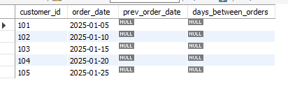
SELECT
customer_id,
order_date,
MAX(order_date) OVER (PARTITION BY customer_id) AS last_order_date
FROM orders;

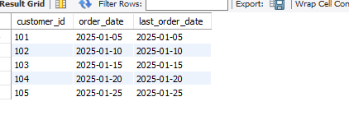
Project 3: Employee Ranking Dashboard
• Objective: Create a dashboard of employee rankings by performance score, ranked within their respective departments. • Technique: Use DENSE_RANK() OVER (PARTITION BY department ORDER BY performance_score DESC) and then display the results
SELECT * FROM employees_performance
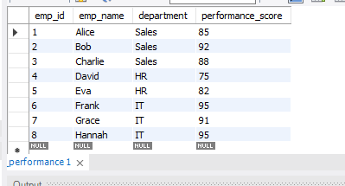
SELECT
emp_id,
emp_name,
department,
performance_score,
DENSE_RANK() OVER (
PARTITION BY department
ORDER BY performance_score DESC
) AS dept_rank
FROM employees_performance
ORDER BY department, dept_rank;

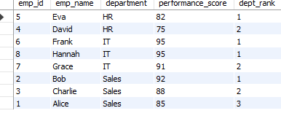

Project 2: Customer Churn Analysis
• Objective: Identify customers with long gaps between orders. • Technique: Use LAG() on order_date to calculate the difference between the current order and the previous one for each customer, and then filter for large gaps.

SELECT * FROM orders;
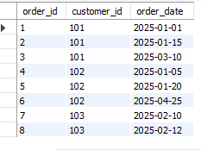

SELECT
customer_id,
order_id,
order_date,
LAG(order_date) OVER (PARTITION BY customer_id ORDER BY order_date) AS previous_order_date,
DATEDIFF(order_date, LAG(order_date) OVER (PARTITION BY customer_id ORDER BY order_date)) AS days_gap
FROM (
SELECT
customer_id,
order_id,
order_date
FROM orders
) AS t;

